**High Level Design (HLD)**

**Data Visualization of Bird Strikes between 2000 – 2011**

**by**

**Ankit Anshu**

**Contents**

Abstract.....................................................................................................................................3

1 Introduction ..........................................................................................................................4

2 General Description ..............................................................................................................4

2.1 ProblemStatement...............................................................................................................4

2.2 Tools used...........................................................................................................................5

3 Design Details........................................................................................................................5

3.1 Functional Architecture ......................................................................................................5

4 KPIs........................................................................................................................................6

5 Deployment............................................................................................................................6

**Abstract**

Transport and communication are one of the crucial domains in field of analytics. Environmental impacts and safety are, nowadays, two major concerns of the scientific community with respect to transport scenarios and to the ever-growing urban areas. These issues gain more importance due to the increasing amount of vehicles and people. Seeking for new solutions is reaching a point where available technologies and artificial intelligence, especially MAS, are being recognized as ways to cope and tackle these kinds of problems in a distributed and more appropriate way. A bird strike is strictly defined as a collision between a bird and an aircraft which is in flight or on a take-off or landing roll. The term is often expanded to cover other wildlife strikes - with bats or ground animals. Bird Strike is common and can be a significant threat to aircraft safety. For smaller aircraft, significant damage may be caused to the aircraft structure and all aircraft, especially jet-engine ones, are vulnerable to the loss of thrust which can follow the ingestion of birds into engine air intakes. This has resulted in several fatal accidents. Bird strikes may occur during any phase of flight, but are most likely during the take-off, initial climb, approach and landing phases due to the greater numbers of birds in flight at lower levels. To have a closer look the following document visually depicts the data collected on Bird Strikes by FAA between 2000-2011.’

**1. Introduction**

Over the past few years there has been increasing attention focused on the potential risks’ wildlife pose in aviation. While the civil and military communities recognize the threat of wildlife strikes, incidents such as the forced emergency landing of US Airways Flight 1549 in the Hudson River in 2009 have brought it into the public eye making us more aware of the potential dangers. According to the FAA the threat of wildlife strikes is increasing. The number of annual strikes reported has increased from 1,793 in 1990 to 9,474 in 2009. The Federal Aviation Administration (FAA) has had ongoing efforts and is involved in programs to improve the situation. One of its efforts includes developing a voluntary reporting system to collect wildlife strike related data. This data is available to the public in the FAA Wildlife Strike Database. e this report offered multiple tables of data and a few graphs; it is quite lacking in visualizations of the data contained in the FAA Wildlife Strike Database. In our paper we explore the data in the FAA Wildlife Strike Database and demonstrate how various information visualizations can be applied to the data to reveal patterns and facts which could help in understanding the data and in creating mitigation plans to avoid these safety risks. For instance, can the data reveal to us whether or not airports are doing all they can to minimize wildlife strikes? Can the use of visualizations reveal any problems that the FAA’s analysis has not already revealed?

**2. General Description**

**2.1 Problem Statement**

Wildlife strikes are the consequence of various factors. These factors include migration of species, weather, time-of day, phase of flight and the region of the flight’s route. However, some of the practical questions remain to be addressed with concrete observational data. For example, how exactly are various factors related and to what extent do they impact wildlife strikes on airplanes? In this project, we focus on the aforementioned factors and tried to ascertain levels of contribution for each factor.

**2.2 Tools used**





**3. Design Details**

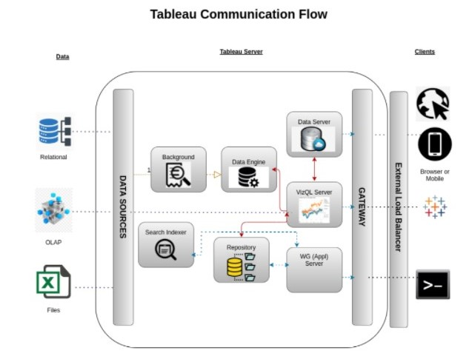

**4. KPIs (Key Performance Indicators)**

Key indicators displaying a summary of Data Visualization of Bird Strikes between 2000-2011.

1. Visuals Depicting the Number of Bird Strikes

1.2 Yearly Analysis 1.1.2 Bird Strikes in US

1.3 Top 10 US Airlines in terms of having encountered bird strikes

1.4 Airports with most incidents of bird strikes – Top 10

2 Yearly Cost Incurred due to Bird Strikes:

3 When do most bird strikes occur?

3.1 Altitude of airplanes at the time of strike

3.2 Phase of flight at the time of strike.

3.3 Average Altitude of the airplanes in different phases at the time of strike

4 Effect of Bird Strikes

4.1 Impact on Flight

4.2 Effect of Strike at Different Altitude

4.3 Were Pilots Informed?

4.4 Prior Warning and Effect of Strike Relation

**5. Deployment**

Tableau’s analytics platform offers three different deployment options depending on your

environment and needs. The below graphic shows each option at a glance:

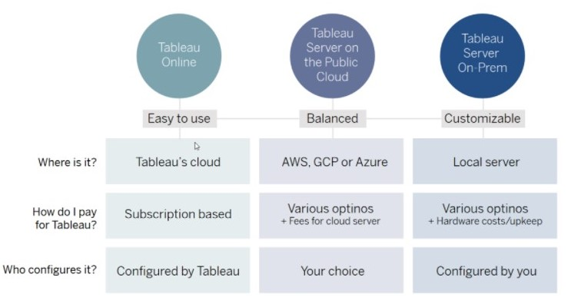

For this project we use Tableau public. Tableau public is free version of Tableau.

**Pros and Cons of Tableau public:**

**Pros:**

* Data visualization: lots of different options, including bar, scatter, pie, waterfall charts to explore relationships between variables, and to present findings/trends to different teams
* Integrates readily with limited, though different data sources: TXT, CSV, TDE, Access
* Exports reports for review of different dashboards: client-ready/team-ready, with a clean and tidy presentation in PDF format (or hardcopy)

**Cons:**

* The biggest drawback to the public version of Tableau is that any data used in the program is 'public' and therefore not secure: workbooks are saved to the cloud, rather than locally
* Tableau Public limits data ingestion to 10 million rows per source
* Limited connections - can't connect to SQL databases to ingest data (must be through CSV, Access, TDE, or text files)